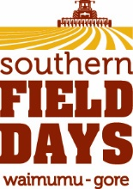
Alcohol Form
Please fill out and return to the office
office@southernfielddays.co.nz

Company Name | Site No
Person Responsible | Cell
At Southern Field Days we want to get everyone home safe. You can do your part by working with us on this form. Please ensure you initial in the column provided once you have read each statement.
We will serve alcohol responsibly or not at all.
We will not serve intoxicated persons.
We will not serve minors.
No ID no service, no exceptions
We will not allow intoxicated persons to enter or remain on the premises.
We will provide and promote a wide range of non-alcoholic beverages.
We provide and promote our food.
These terms and conditions are strongly communicated to your staff and helpers
If you don’t adhere to our obligations under the Sale and Supply of Alcohol Act, then you potential face a ban from providing and or supplying alcohol. It is important we act responsibly.
Signature

Please print your name | Date

